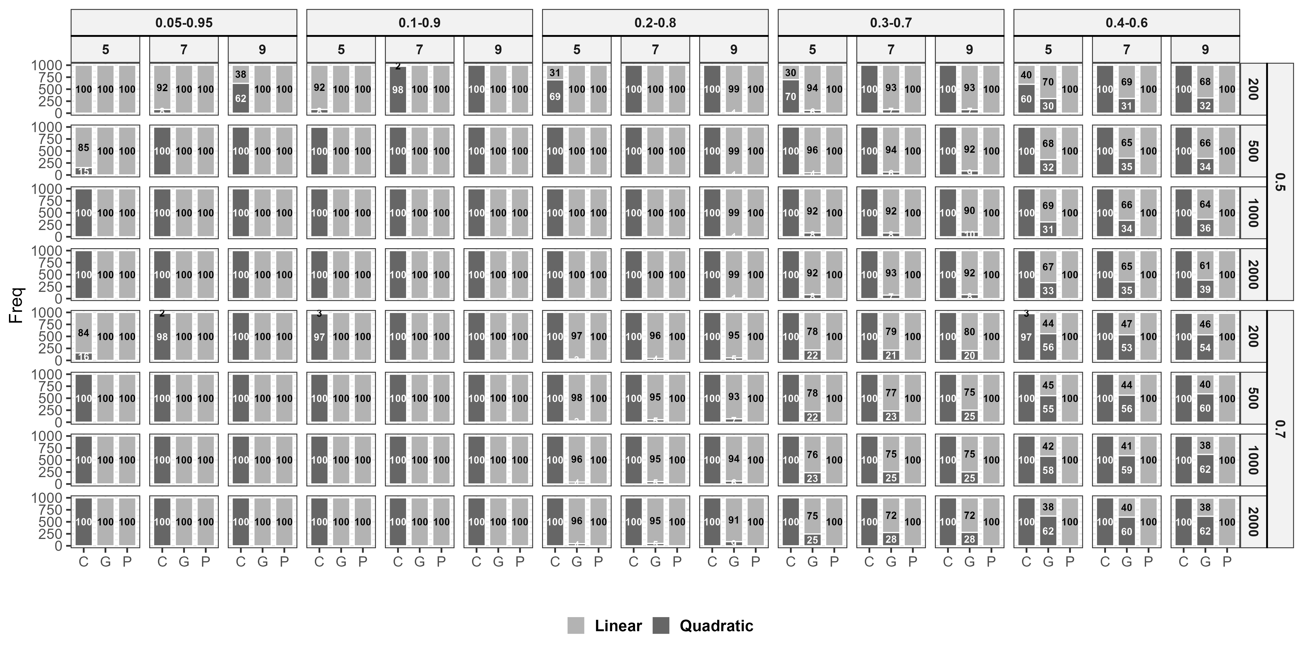

Figure 4.4. Results of identification rates for linear or quadratic patterns across the sample sizes, the size of ICC, the number of timepoints, and censoring proportion

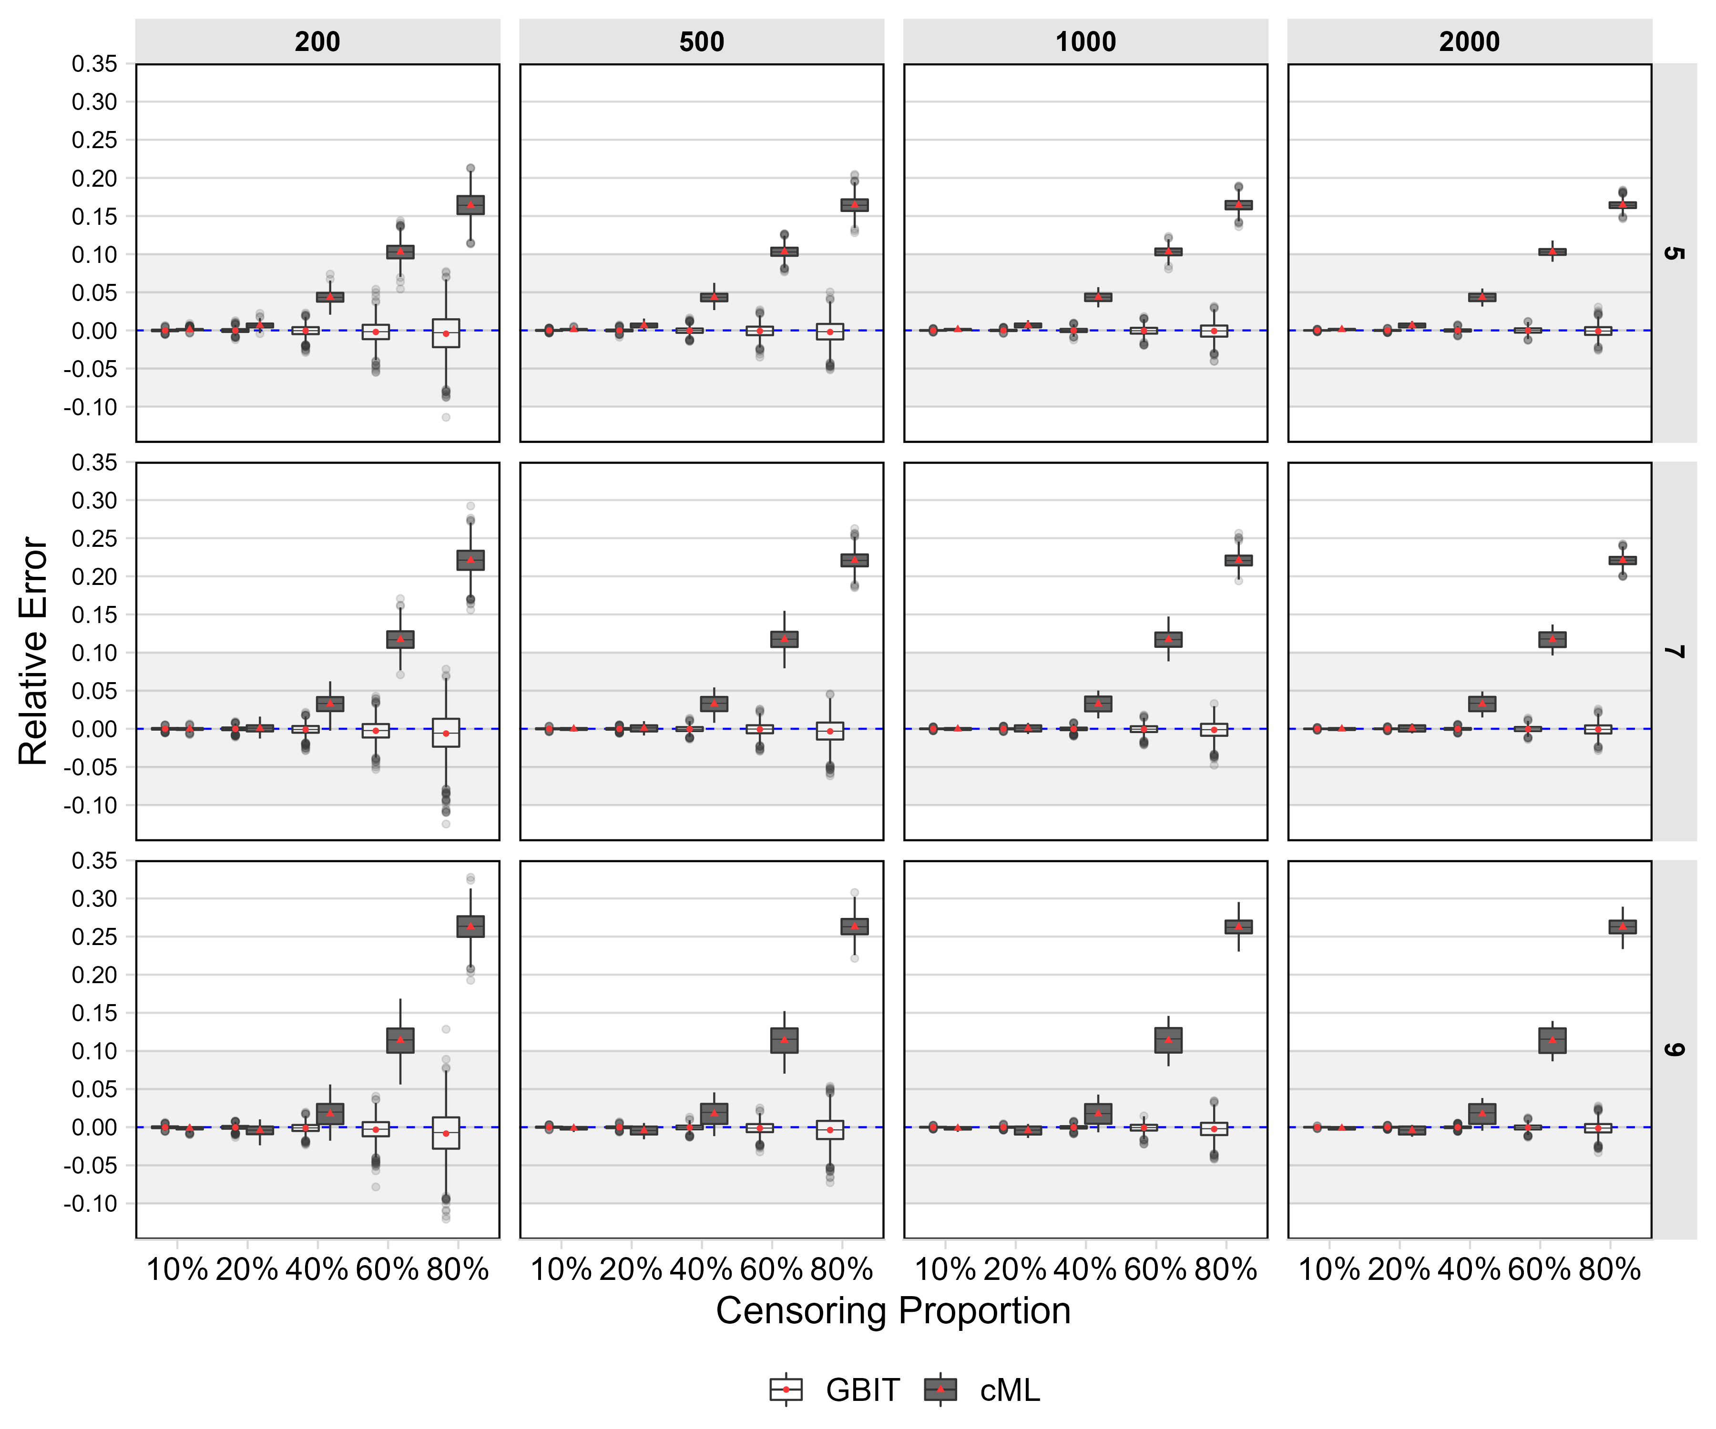

Figure 4.5. Results of the errors of the means of growth intercepts across the sample sizes and the number of timepoints.

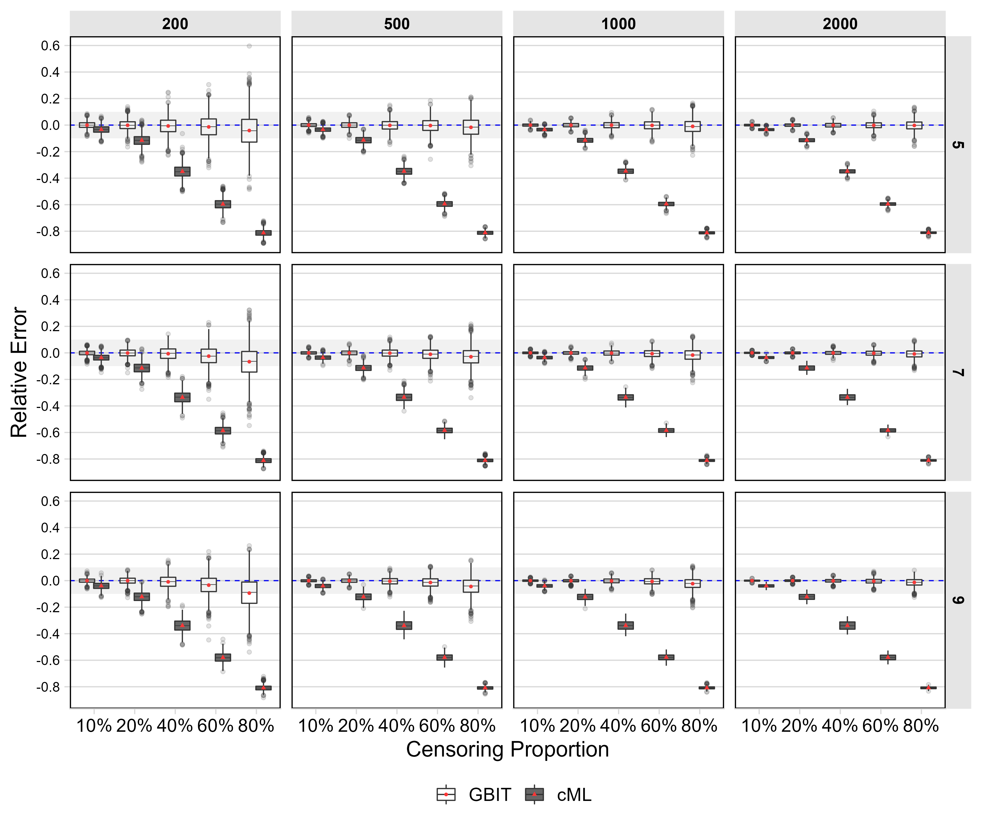

Figure 4.6. Results of the errors of the means of growth slopes across the sample sizes and the number of timepoints.

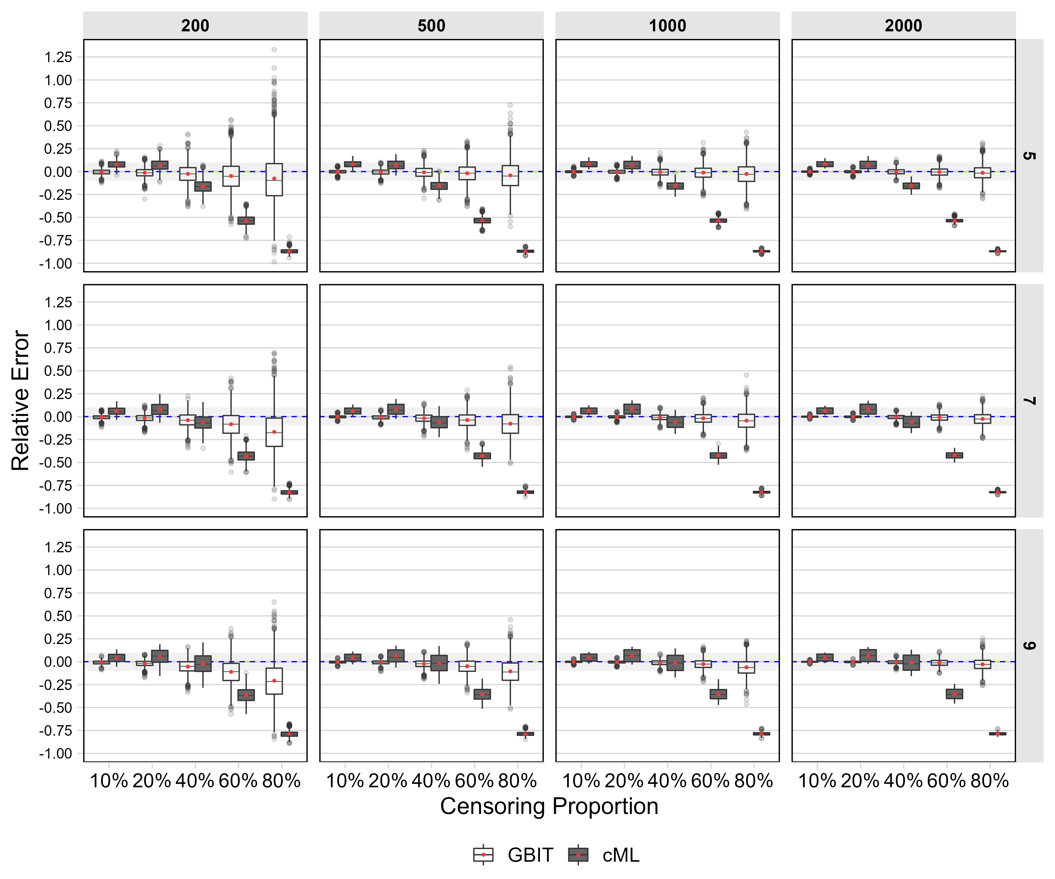

Figure 4.7. Results of the errors of the variances of growth intercepts across the sample sizes and the number of timepoints.

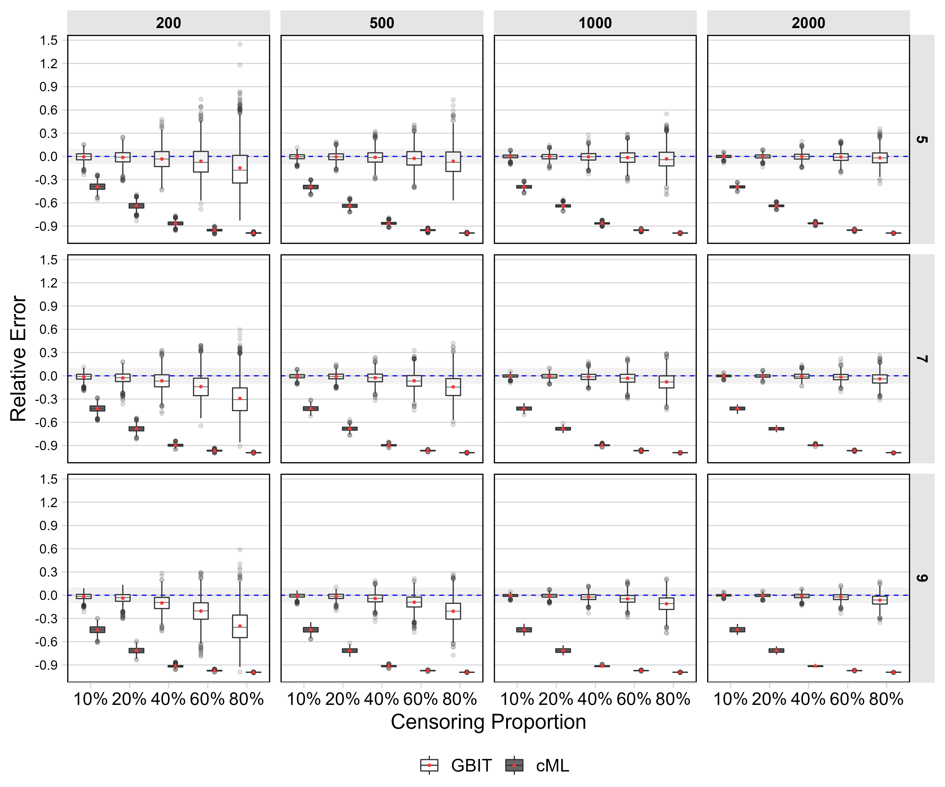

Figure 4.8. Results of the errors of the variances of growth slopes across the sample sizes and the number of timepoints.

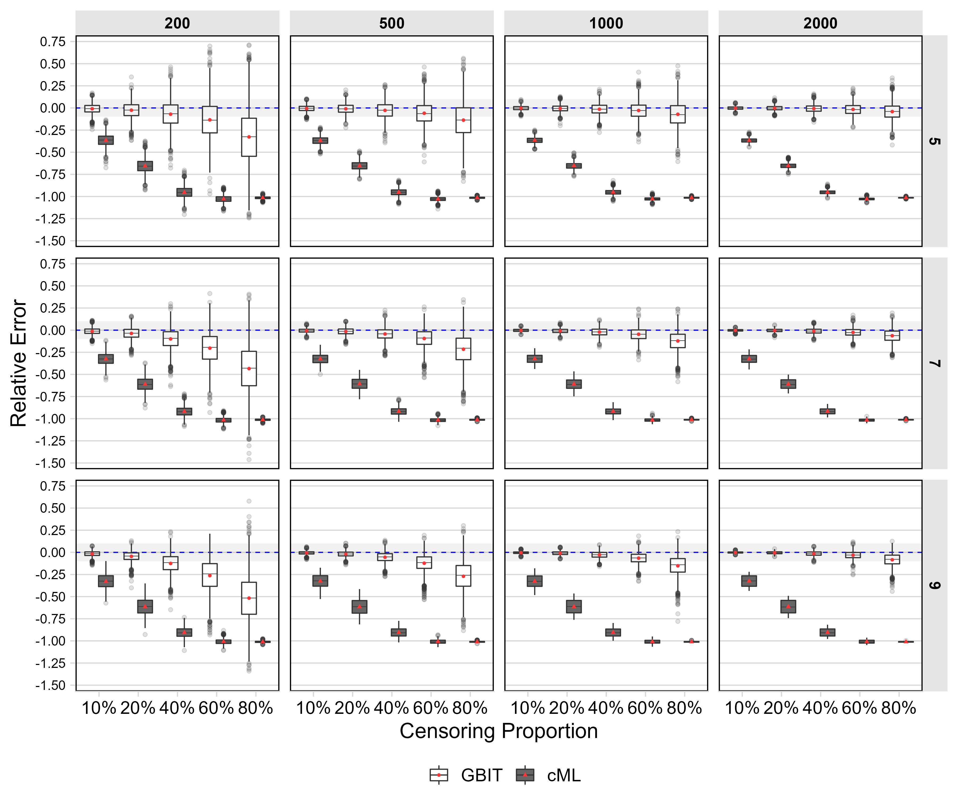

Figure 4.9. Results of the errors of the covariances between growth factors across the sample sizes and the number of timepoints.

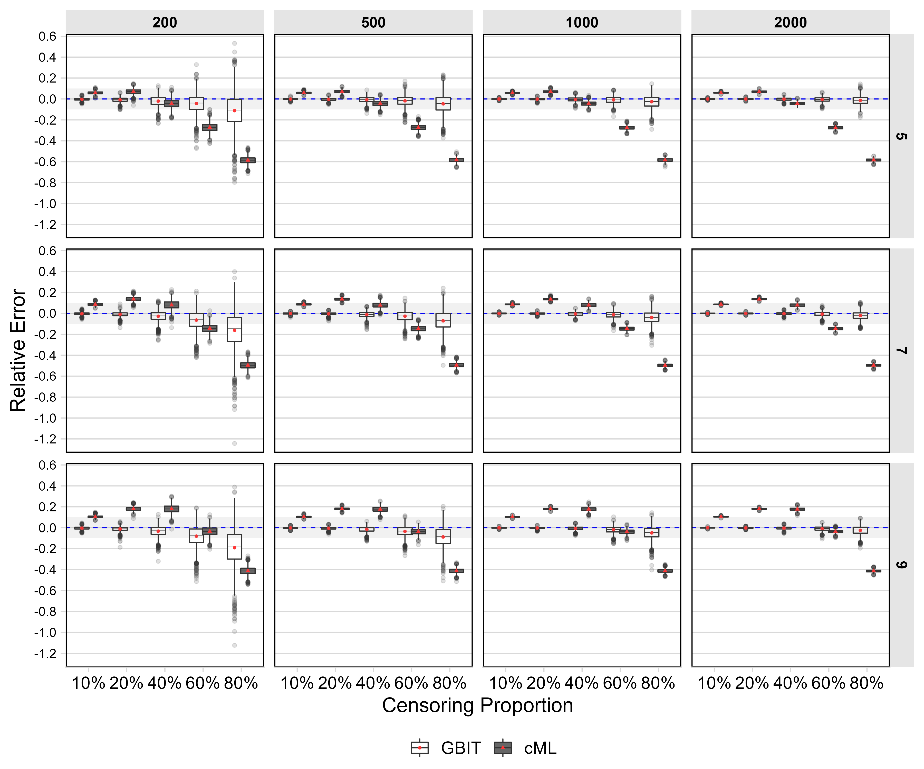

Figure 4.10. Results of the errors of the covariate coefficient on growth intercept across the sample sizes and the number of timepoints.

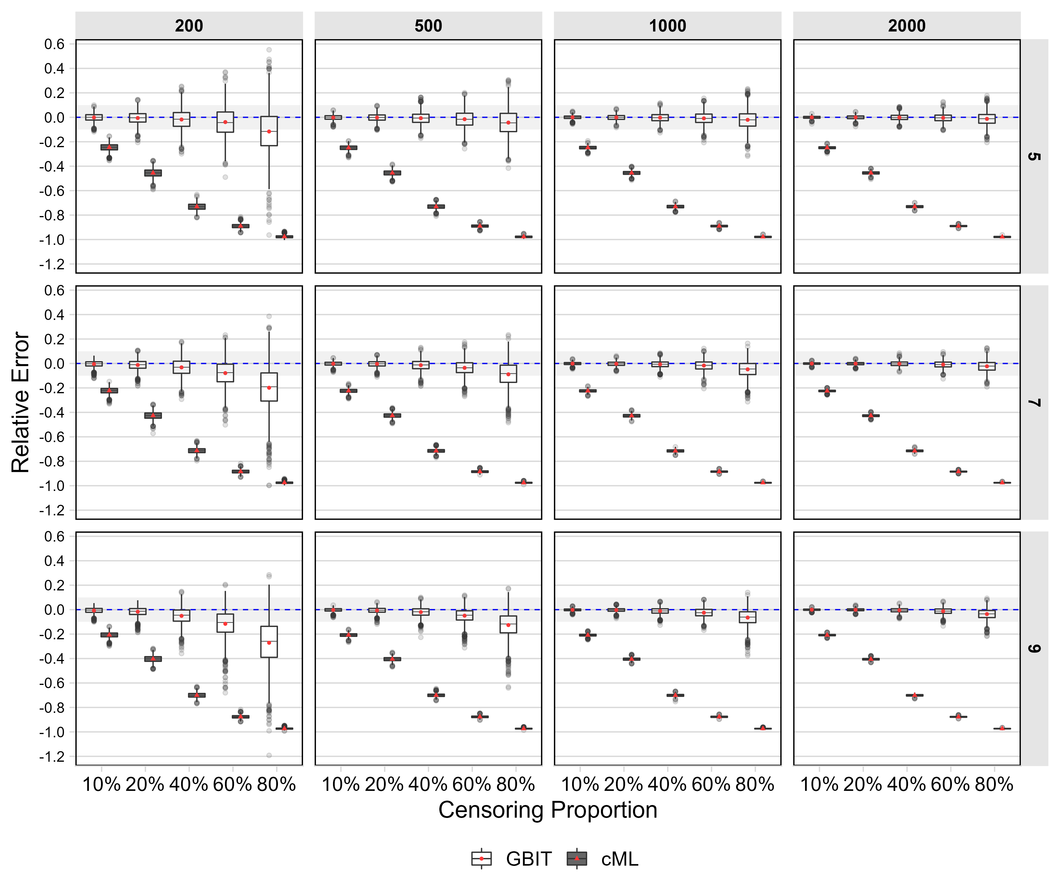

Figure 4.11. Results of the errors of the covariate coefficient on growth slope across the sample sizes and the number of timepoints.

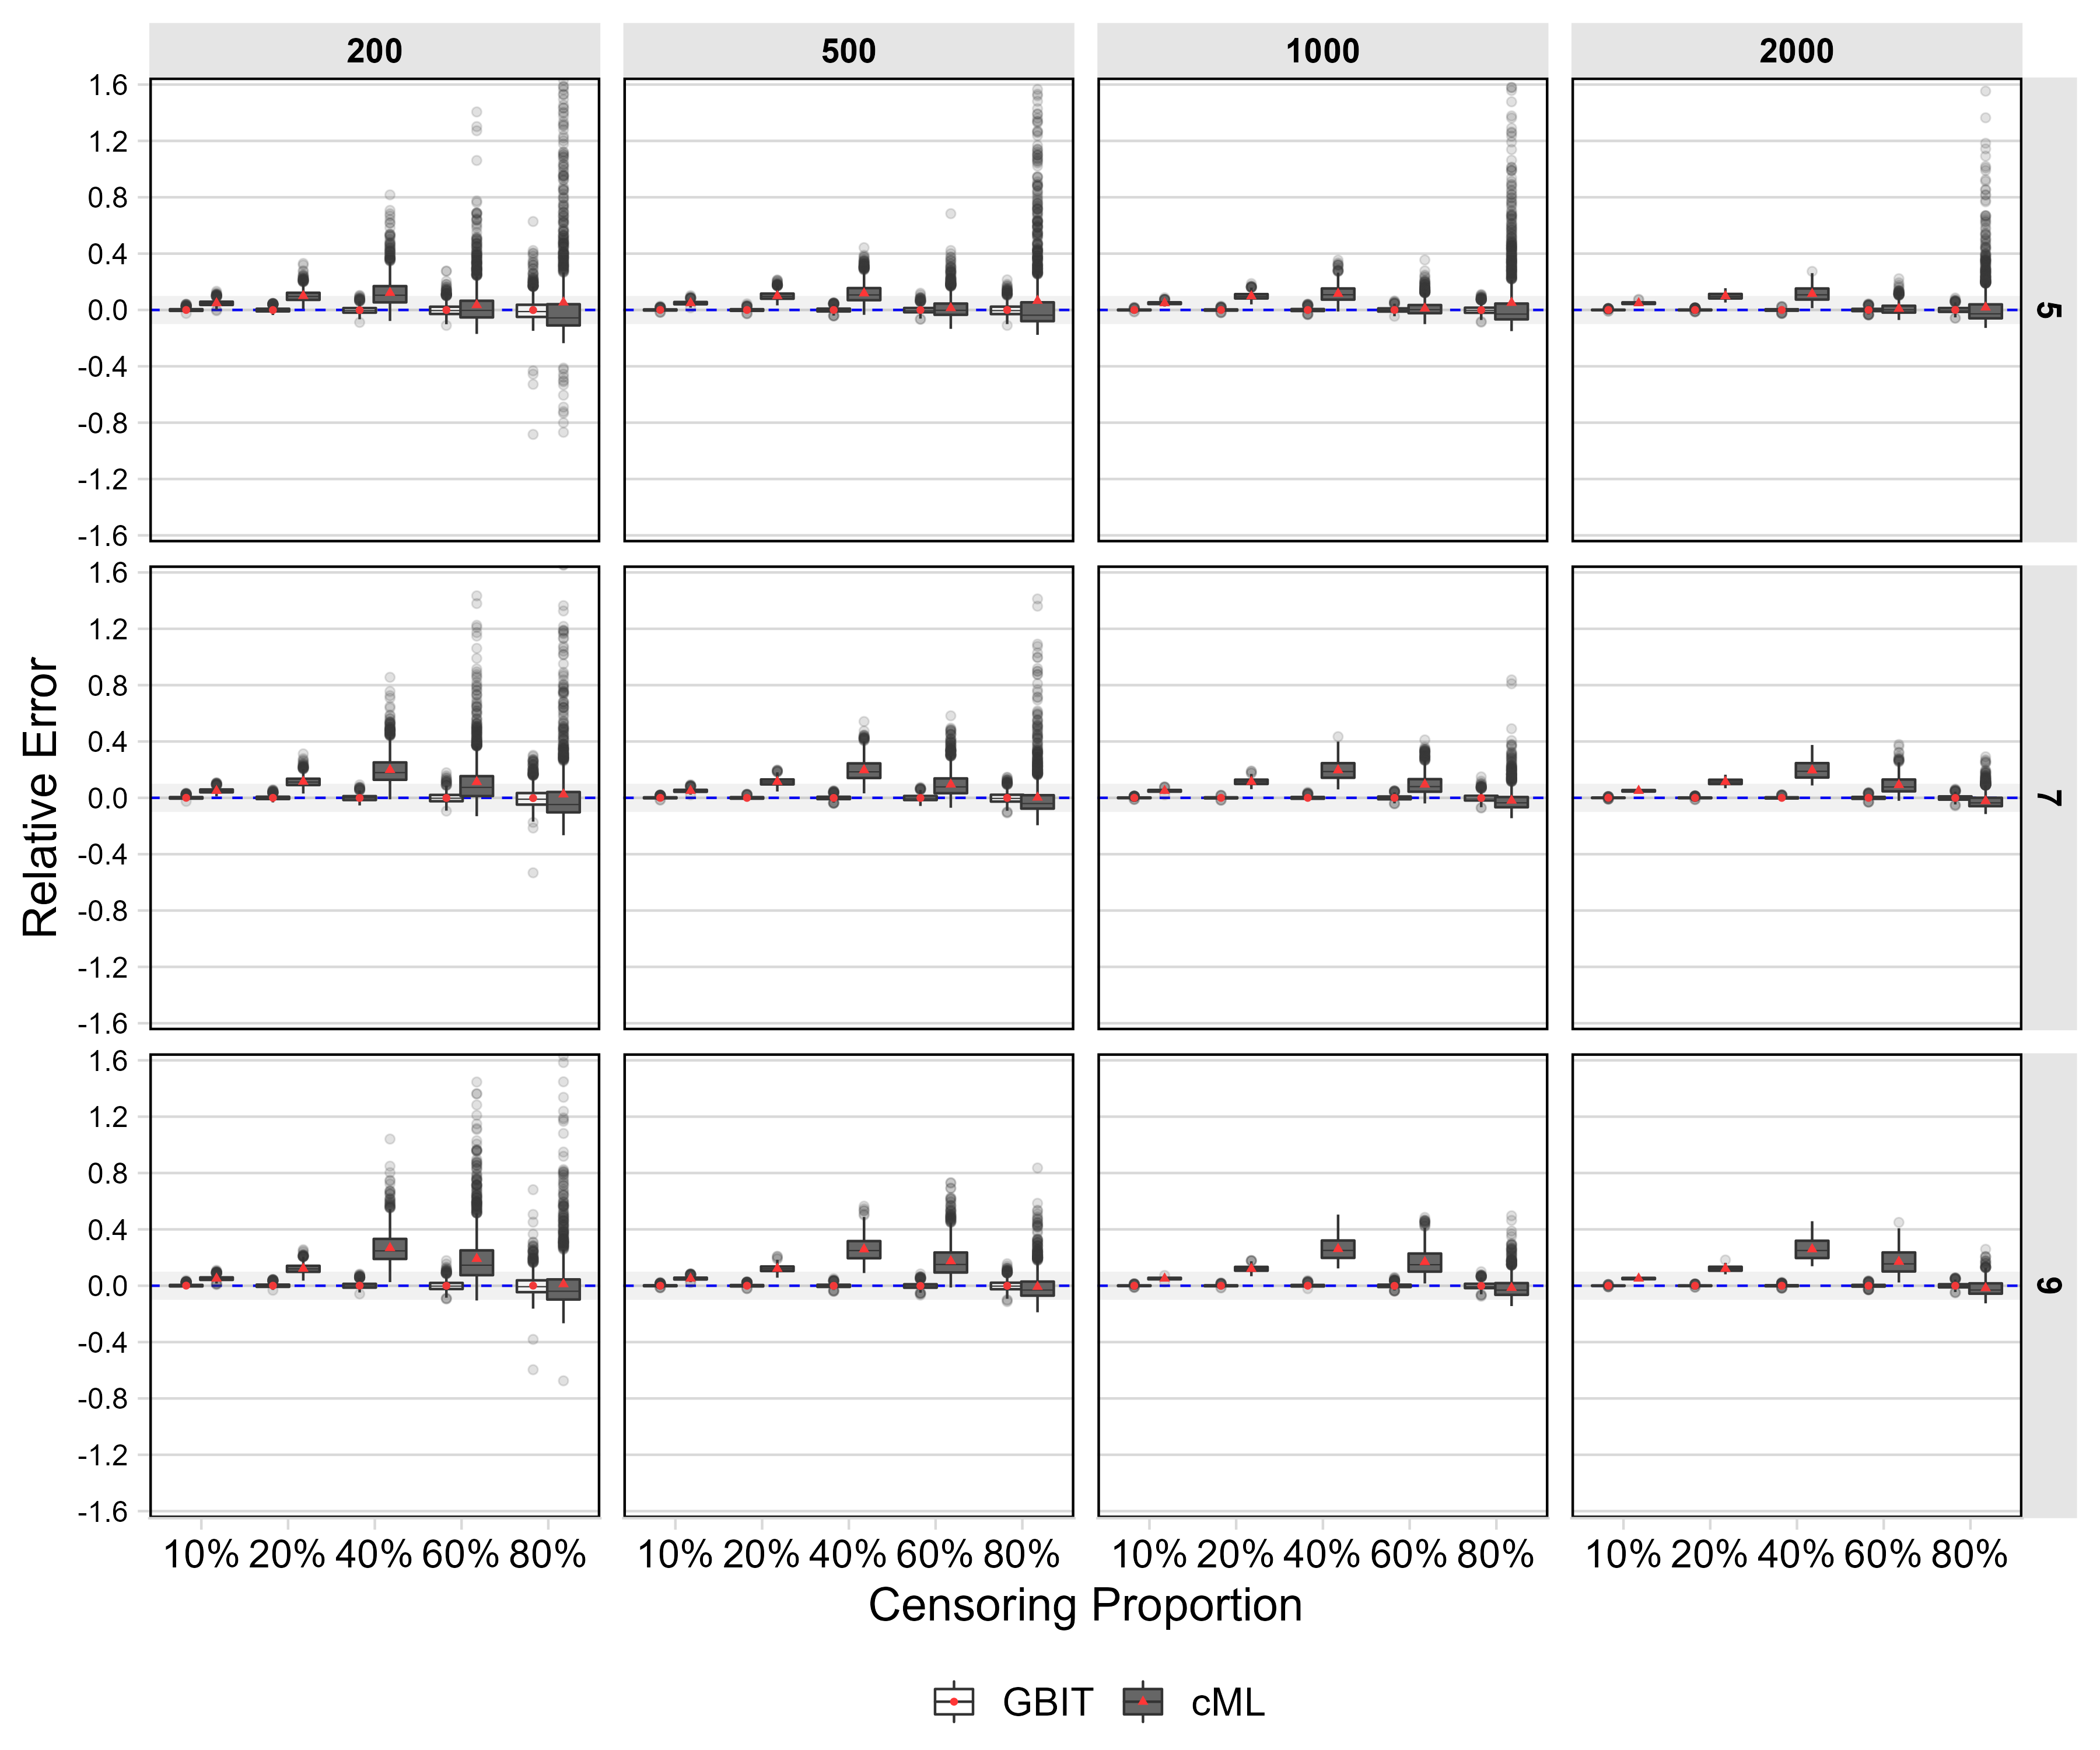

Figure 4.12. Results of the errors of the effects of growth intercept on the distal outcome across the sample sizes and the number of timepoints.

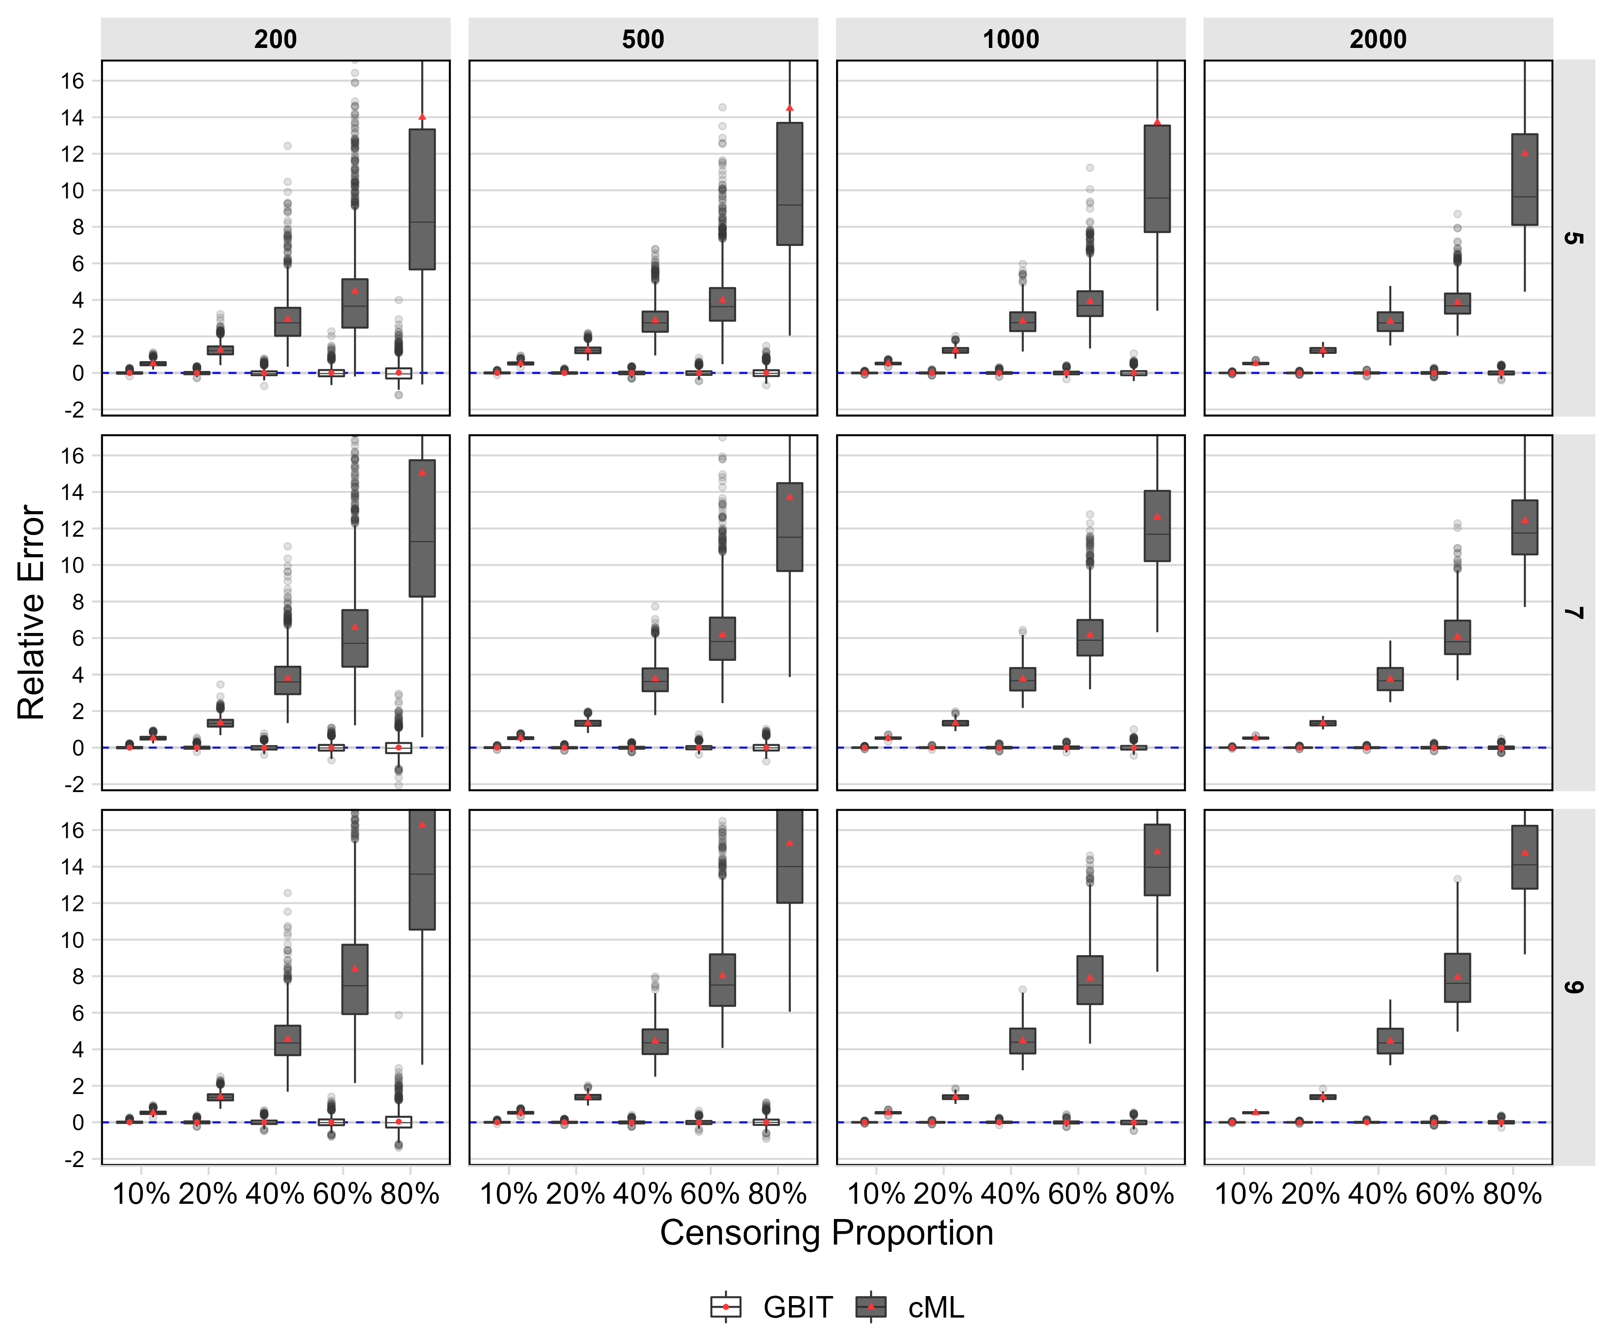

Figure 4.13. Results of the errors of the effects of growth slope on the distal outcome across the sample sizes and the number of timepoints.